West Podium Art Wall opens to the public March 15, 2019

As part of Related Companies’ Hudson Yards development, James Carpenter Design Associates has designed a rippled facade that multiplies the presence of the sky and plaza intersected by the arcing passage of the sun.

New York, NY – March 15, 2019 – Opening to the public on March 15, the Hudson Yards is a new 26-acre neighborhood on the west side of Manhattan built over a working rail yard. The mixed-use complex is organized around a public square adjacent to the Hudson River to the west. James Carpenter Design Associates was commissioned by Related Urban to design the west-facing podium art wall for 20 Hudson Yards, a large retail complex between two towers designed by KPF. The art wall becomes the facade to the Hudson Yard Shops and establishes the dynamic threshold for a public square where the Hudson River Park, the High Line and the Hudson Park and Boulevard intersect with the Culture Shed and Thomas Heatherwick’s stepped vessel sculpture.

The 300’ long cable-net supports glass panels inclined to capture the sky and curved along their top edge to capture the plaza landscape and activity below. The horizontal rhythm of the wall simultaneously captures and compresses the activities of the sky and landscaped plaza, reflecting a linear repetition of sky and plaza that echoes the rippled surface reflections of the Hudson River. At times, the 90’ high wall appears to lean back to absorb the western sky, while in the afternoon, the repeated image of the sun reflected in the wall’s curves, describes an arc reminiscent of the afternoon sun setting over the river.

Please contact JCDA with questions or to schedule interviews at ben.colebrook@jcdainc.com. A comprehensive press release of the project will be released once images become available.

About James Carpenter Design Associates
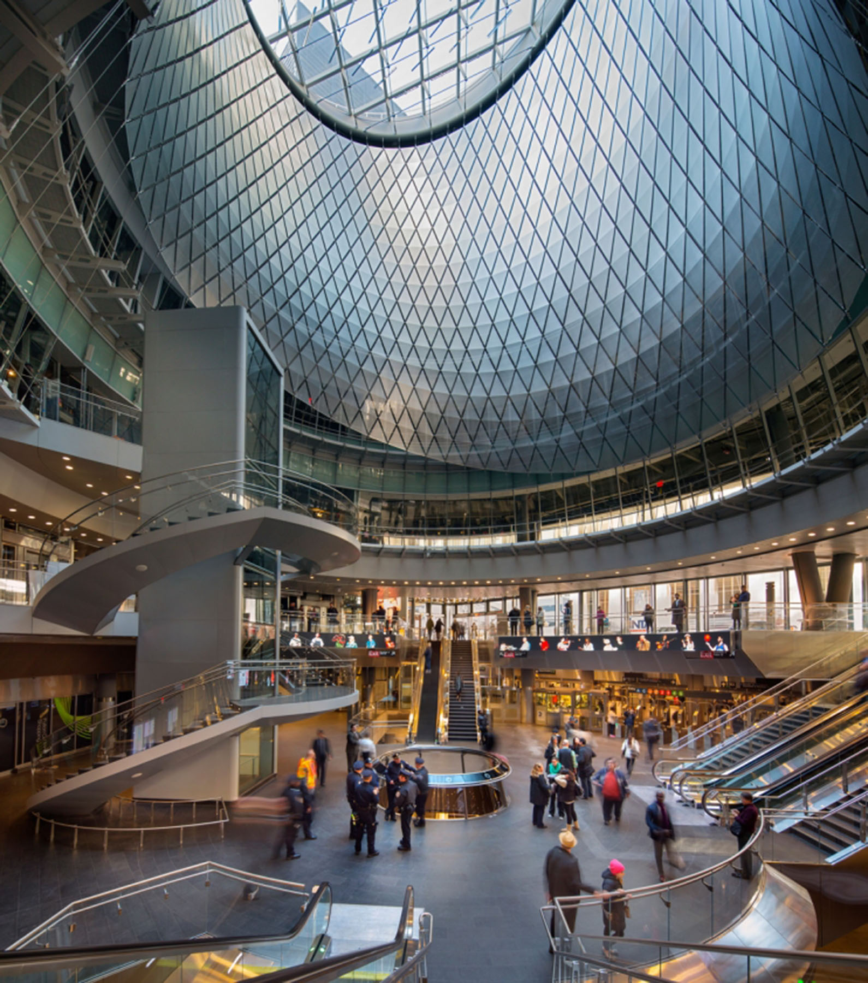
James Carpenter Design Associates is an internationally recognized, award winning design firm founded in 1979. The firm is a cross-disciplinary practice working at the intersection of Architecture, Fine Arts and Engineering and is recognized for it’s innovative and distinctive approach to the use of natural light which serves as the foundation of its design philosophy. JCDA brings a deep technical knowledge and artistic sensibility to its building projects and planning for cultural and institutional clients, leveraging this expertise to exploit the aesthetic and performative aspects of natural light at a variety of scales.

JCDA is well know for its transformative civic artworks such as the “Sky Reflector-Net” (2004-2014) in Lower Manhattan’s Fulton Center transit hub and the Hearst Tower’s “Ice Falls” (2002-2006). Larger scale projects include the Israel Museum’s expansion and renewal (2005-2011), an 18 acre campus in Jerusalem. Having recently completed the expansion and renewal of the Museum at the Gateway Arch (2008-2018) below Eero Saarinen’s famous arch in St. Louis, JCDA is currently undertaking the planning and design of the Bornholms Kunstmuseum expansion on the island of Bornholm in Denmark.

Press contact: Ben Colebrook 145 Hudson Street, 4th Floor, New York, NY 10013 T 212-431-4318 ben.colebrook@jcdainc.com

